**FNB Enhances Bank Operations With New Structure**

*Justin Kurth Leads Streamlined Operations Organization Focused on Risk Management, Efficiency and Innovation*

**PITTSBURGH, PA – June 17, 2024** – F.N.B. Corporation (NYSE: FNB), the parent Company of First National Bank, today announced it has enhanced its Bank Operations with a single, streamlined reporting structure. The updates are designed to enable FNB to more effectively apply automation, drive efficiency and innovation, further strengthen FNB’s focus on risk management and create a superior customer experience.

Justin Kurth leads the merged Bank Operations organization in his new role as Executive Vice President, Director of Banking Enterprise Operations. In addition to his oversight of the Customer Contact Center, Retail Branch Operations and Compliance and Emergent Risk, he adds responsibility for Loan Operations and Efficiencies as well as Deposit Operations and Processing. This comprehensive view of Bank Operations positions Kurth to implement process improvements to foster productivity, resilience and stability as FNB prepares for heightened regulatory standards that apply when financial institutions cross $50 billion in assets.

“FNB is focusing on being competitive in a rapidly changing environment where our effective adoption of emerging technology and ability to meet heightened risk management expectations are critical to our continued success, especially as we reach new milestones in our growth,” said Vincent J. Delie, Jr., Chairman, President and Chief Executive Officer of F.N.B. Corporation and First National Bank. “Justin has used innovation to increase efficiency and accuracy while leading Retail Operations and our Contact Center, resulting in an improved customer experience overall. His analytical mindset and proven capacity to drive transformation make him a strong fit to lead our operations within this new structure.”

FNB also has hired James Craske as Director of Operational Risk and Support Services. Reporting to Kurth, Craske is responsible for executing strategies to effectively manage operational risk throughout the Company, including continuing to enhance FNB’s processes for identifying, assessing and mitigating risk.

Delie added, “James will focus on building enhancements to FNB’s operational reporting and tracking systems, which will enable our support teams to improve efficiency, productivity, customer satisfaction and risk management. These tools will be instrumental as we continue to build out our first line of defense within our enterprise risk management framework.”

Prior to joining FNB in 2020 as Executive Director of Retail Banking Operations, Kurth served as Director of Retail Lending and Head of Branch Transformation at Investors Bank and in a variety of retail banking leadership roles at Citi. A graduate of the University of California, Riverside, Kurth reports to Vince Calabrese, Chief Financial Officer of F.N.B. Corporation and

First National Bank.

Craske brings more than 25 years of financial services experience to the role, having spent the past seven years at Citi, most recently as Senior Vice President of Citi Global Wealth, Strategic Investments. He earned his bachelor’s degree from Whitman College and a master’s degree from Carnegie Mellon University.

**About F.N.B. Corporation**

F.N.B. Corporation (NYSE: FNB), headquartered in Pittsburgh, Pennsylvania, is a diversified financial services company operating in seven states and the District of Columbia. FNB’s market coverage spans several major metropolitan areas, including: Pittsburgh, Pennsylvania; Baltimore, Maryland; Cleveland, Ohio; Washington, D.C.; Charlotte, Raleigh, Durham and the Piedmont Triad (Winston-Salem, Greensboro and High Point) in North Carolina; and Charleston, South Carolina. The Company has total assets of nearly $46 billion and approximately 350 banking offices throughout Pennsylvania, Ohio, Maryland, West Virginia, North Carolina, South Carolina, Washington, D.C. and Virginia.

FNB provides a full range of commercial banking, consumer banking and wealth management solutions through its subsidiary network, which is led by its largest affiliate, First National Bank of Pennsylvania, founded in 1864. Commercial banking solutions include corporate banking, small business banking, investment real estate financing, government banking, business credit, capital markets and lease financing. The consumer banking segment provides a full line of consumer banking products and services, including deposit products, mortgage lending, consumer lending and a complete suite of mobile and online banking services. FNB's wealth management services include asset management, private banking and insurance.

The common stock of F.N.B. Corporation trades on the New York Stock Exchange under the symbol "FNB" and is included in Standard & Poor's MidCap 400 Index with the Global Industry Classification Standard (GICS) Regional Banks Sub-Industry Index. Customers, shareholders and investors can learn more about this regional financial institution by visiting the F.N.B. Corporation website at [www.fnbcorporation.com](http://www.fnbcorporation.com).

###

**Media Contact:**

Jennifer Reel, 724-983-4856, 724-699-6389 (cell)

reel@fnb-corp.com

**Analyst/Institutional Investor Contact:**

Lisa Hajdu, 412-385-4773  
hajdul@fnb-corp.com



*Justin Kurth*

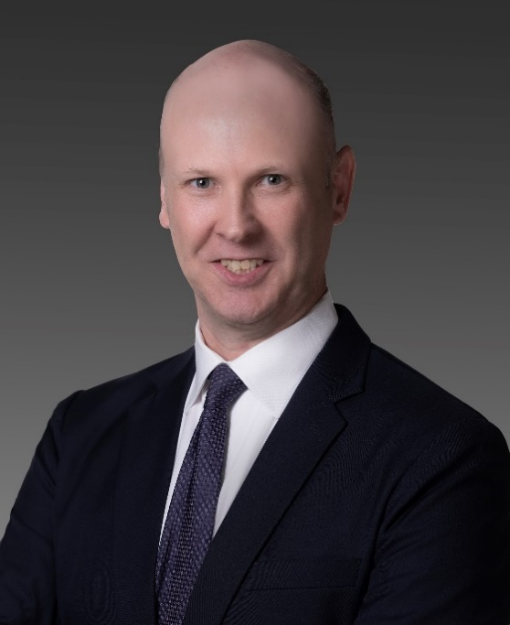

*James Craske*